**Booking Form**

|  |  |
| --- | --- |
| **Contact Name:** |  |
| **Organisation:** |  |
| **Address:** |  |
| **Invoice address if different:** |  |
| **Telephone:** |  |
| **Mobile:** |  |
| **Email:** |  |

|  |  |  |  |  |
| --- | --- | --- | --- | --- |
| **Hire charges (to be paid 7 days in advance)** | **Weekday evenings (17.00 – 21.00)**  **Saturday & Sundays** | | **Monday to Friday daytime**  **(08.00 17.00)** | |
| **Hourly (£)** | **3 hours (£)** | **Hourly (£)** | **3 hours (£)** |
| **MUGA** | 32 | 85 | 30 | 80 |
| **Grass area when booked with MUGA** | 10 | 30 | 10 | 30 |
| **Grass area /Pitch (no goals)** | 32 | 85 | 30 | 80 |
| **Secret Garden** | 20 | 55 | 18 | 50 |
| **Classroom** | 25 | 65 | 22 | 60 |
| **Enterprise Hub** | 20 | 55 | 18 | 50 |
| **Welfare Unit** | 10 | 28 | 10 | 28 |

**\*There are no toilets or changing facilities attached to the MUGA. Toilet facilities can be made available for Pitch users on request.**

|  |
| --- |
| **Please Note For one off events: Full payment is required plus £25 deposit upon booking.**  **(refundable after the event, providing no damage is done and no additional cleaning is required)** |

**Spaces available for hire (please tick)**

|  |  |  |  |  |  |  |  |  |  |
| --- | --- | --- | --- | --- | --- | --- | --- | --- | --- |
| **MUGA** |  | **Football Pitch (no goals)** |  | **Enterprise**  **Hub** |  | **Secret Garden** |  | **Classroom** |  |
| 1 hour |  | 1 hour |  | 1 hour |  | 1 hour |  | 1 hour |  |
| 3 hours |  | 3 hours |  | 3 hours |  | 3 hours |  | 3 hours |  |
| **Welfare Unit** |  |  |  |  |  |  |  |  |  |
| 1 hour |  |  |  |  |  |  |  |  |  |
| 3 hours |  |  |  |  |  |  |  |  |  |

|  |
| --- |
|  |

**Please tick if you would like refreshments**

|  |
| --- |
|  |

**How many attendees?**

|  |  |
| --- | --- |
| **Date/s** |  |
| **Start time:** |  |
| **End Time:** |  |
| **Type of Activity:** |  |
| **Specific requirements:** |  |

**Further Information**

Unless the booking is for the classroom, or it has been specifically agreed in advance, there will not be any access to toilets.

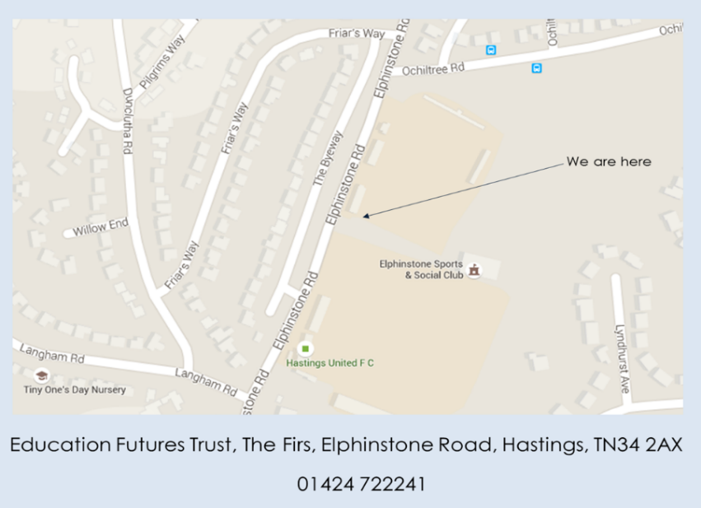Refreshments can be discussed in advance and a quote given.

If traveling by car, visitor parking is in the layby down the side road (South Lane) which leads to Elphinstone Sports and Social Club, between Hastings United Football Club and Education Futures Trust. Please see map.

**Cancellation Policy**

If your plans change and you need to cancel, please inform us as soon as possible.

* **More than 7 days before the booking**: Full refund, minus a £25 deposit.
* **Less than 7 days before the booking**: 50% of the booking fee will be charged.
* **Within 48 hours of the booking**: The full booking fee will be charged.

Thank you for understanding!

**Invoicing**

An invoice will be sent shortly after the booking is confirmed, and payment is due within 10 days. Please complete and sign this form and return it to us. We will send an email to confirm receipt. Please retain a copy for your records.

Signed…………………………………………………… Date ……………………………………..

Thank you for choosing to use our facilities, we hope you enjoy your time at The Firs.